LAB #05

Gain familiarity with Complex Numbers and plot, Complex exponential signals, Real exponential signals



Spring 2023

**CSE-301L Signals & Systems Lab**

Submitted by: MUHAMMAD SADEEQ

Registration No.: 21PWCSE2028

Section: C

“On my honor, as a student of the University of Engineering and Technology, I have neither given nor received unauthorized assistance on this academic work”

Submitted to:

Engr. Sumayyea

(1 April 2023)

Department of Computer systems engineering

University of Engineering and Technology, Peshawar

**Task 1**

**Function Code:**

|  |
| --- |
|  |
|  |
|  |
|  |
|  |
|  |
|  |
|  |
|  |

**Code :**

|  |
| --- |
|  |
|  |
|  |

**Output:**

>> Task1

Z = 3 + j4 Magnitude = 5 Phase = 0.927295 Ph(deg) = 53.130102

**Task 2**

**Function Code:**

|  |
| --- |
|  |
|  |
|  |

**Function Code:**

|  |
| --- |
|  |
|  |
|  |

**Code :**

|  |
| --- |
|  |
|  |
|  |

**Output:**

>> Task2

Z = 0 + j-7 Magnitude = 7 Phase = -1.570796 Ph(deg) = 90.000000

Z = 0 + j-1.428571e-01 Magnitude = 1.428571e-01 Phase = -1.570796 Ph(deg) = -90.000000

**Task 3**

**Code:**

|  |
| --- |
|  |
|  |
|  |
|  |

**Output:**

>> Task3

Enter first Complex number :2+3i

Enter second Complex number :1+3i

Z = 3 + j6 Magnitude = 6.708204e+00 Phase = 1.107149 Ph(deg) = 63.434949

**Task 4**

**Code:**

|  |
| --- |
|  |
|  |
|  |
|  |
|  |
|  |

**Output:**

>> Task4

Enter first Complex number :4+2i

Enter second Complex number :2+2i

Z = 4 + j12 Magnitude = 1.264911e+01 Phase = 1.249046 Ph(deg) = 71.565051

Z = 1.500000e+00 + j-5.000000e-01 Magnitude = 1.581139e+00 Phase = -0.321751 Ph(deg) = -18.434949

**Task 5**

**Code:**

|  |
| --- |
|  |
|  |
|  |
|  |
|  |
|  |
|  |
|  |
|  |
|  |
|  |
|  |
|  |
|  |
|  |
|  |
|  |
|  |
|  |
|  |

**Output:**

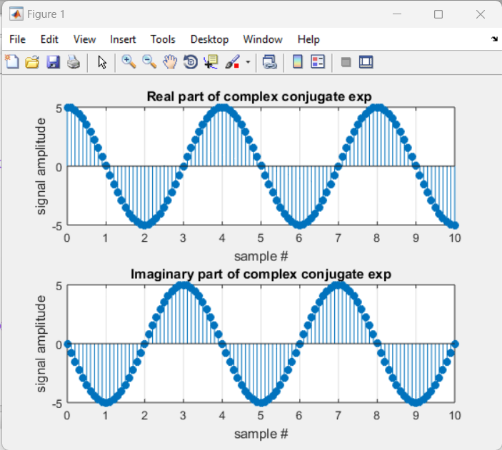

**Task 6**

**Code:**

|  |
| --- |
|  |
|  |
|  |
|  |
|  |
|  |
|  |
|  |
|  |
|  |
|  |
|  |
|  |
|  |
|  |
|  |
|  |
|  |

**Output:**

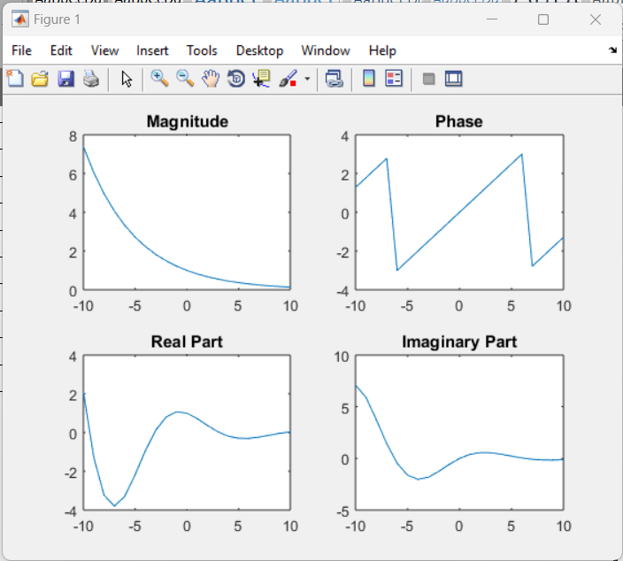

**Task 7**

**Code:**

|  |
| --- |
|  |
|  |
|  |
|  |
|  |
|  |
|  |
|  |
|  |
|  |
|  |
|  |

**Output:**

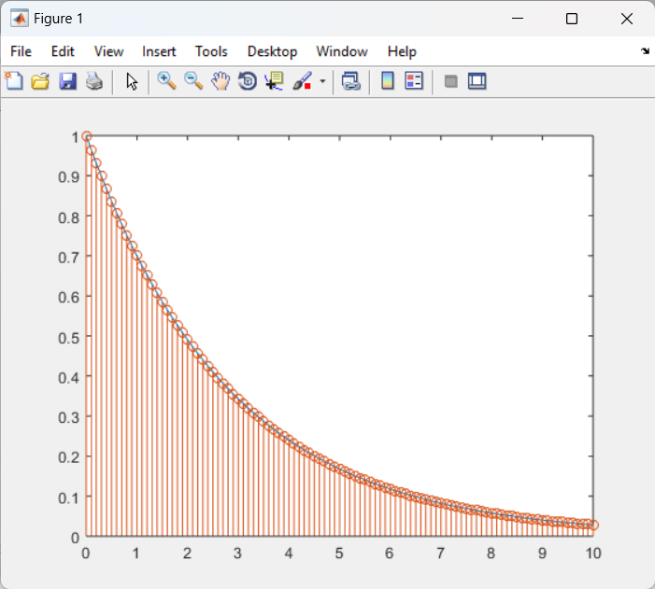

**Task 8**

**Code:**

|  |
| --- |
|  |
|  |
|  |
|  |
|  |
|  |
|  |
|  |
|  |
|  |
|  |
|  |
|  |
|  |
|  |
|  |
|  |
|  |
|  |
|  |
|  |
|  |
|  |
|  |
|  |
|  |
|  |
|  |
|  |
|  |
|  |
|  |
|  |
|  |
|  |
|  |

**Output:**

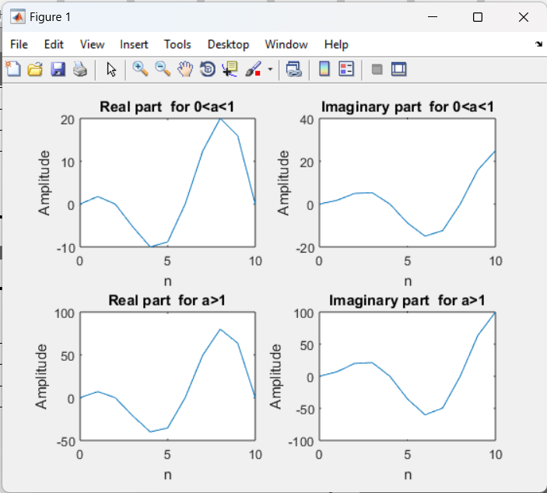

**Task 9**

**Code:**

|  |
| --- |
|  |
|  |
|  |
|  |
|  |
|  |
|  |
|  |
|  |
|  |
|  |
|  |
|  |
|  |
|  |
|  |
|  |
|  |
|  |
|  |

**Output:**

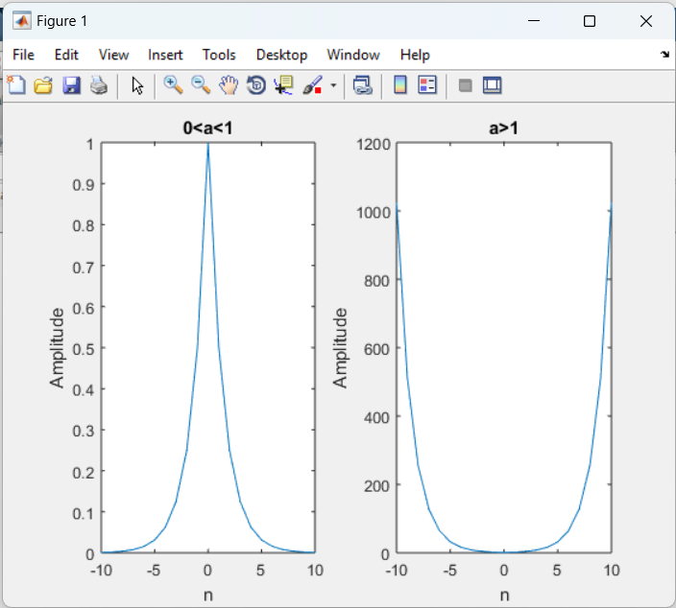

**Task 10**

**Code:**

|  |
| --- |
|  |
|  |
|  |
|  |
|  |
|  |
|  |
|  |
|  |
|  |
|  |
|  |
|  |
|  |
|  |
|  |
|  |
|  |
|  |

**Output:**

